Partial Differential Equations
The method of Separation of Variables

Foreward:
- The general theory of partial differential equation is an advanced topic. Nevertheless, the method of solution by separation of variables is closely related to the boundary value problems for ordinary differential equations.
- The method of separation of variables is applicable to linear partial differential equations; a typical example is the wave equation
u_{xx}=u_{tt}.
- In the application of the method of separation of variables one assumes that the unknown function is of the form u(x,t)=X(x)T(t). Then the equation u_{xx}=u_{tt} reduces to
X’’T=XT’’,
where prime denotes ordinary differentiation with respect to the relevant independent variable. Dividing by X(x)T(t) we obtain
X’’/X=T’’T
- As both sides of this equation are functions of different variables, they should be equal to a constant, say k. Thus we finally get ODE’s
X’’=kX, T’’=kT.
Thus the problem is reduced to a set of ODE’s.
- The boundary conditions are crucial in solving these ODE’s. Thus one needs to learn about the boundary value problems for ODE’s.
- The possibility of solving the problem by separation of variables depends both on the differential equation and on the boundary conditions. It is necessary to choose appropriate coordinate systems, adopted to the problem and write the differential equation in these coordinates. In these notes we consider ODE’s in Cartesian coordinates only.
- Since the equations are linear, superposition of solutions is again a solution. For the periodic case, superposition of solutions leads to a Fourier series. Thus one needs to study Fourier series.
- The Hear equation, the wave equation and Laplace’s equation are typical examples that are common and important applications. We give on outline of the solutions and refer the reader to the textbook for a complete solution.

Textbook:

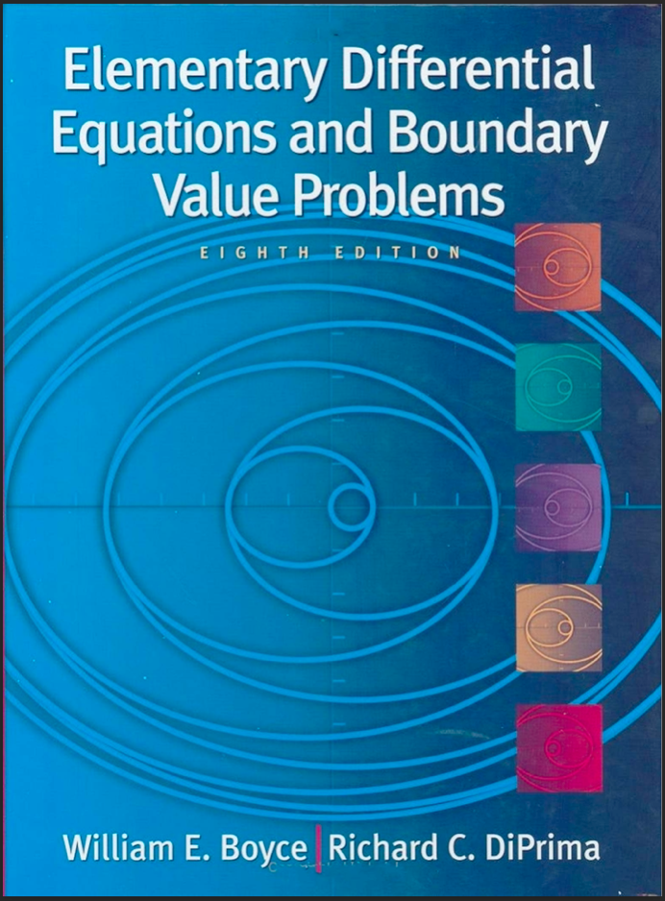
Elementary differential equations and boundary value problems
William $E$. Boyce, Richard C. DiPrima.
8th Edition

Two-Point Boundary Value Problems (Textbook Ch 10.1)
- For a Two-Point Boundary Value Problem dependent variable y or its derivative y’ is specified at two different points.
$$y\left(α\right)=y_{0}, y(β)=y_{1}$$
- Finding function y solution, with the given functions $p,q,g$ and additional two boundary conditions, is a two-point boundary value problem.:
$x_{1}<x_{2}, y_{1},y_{2}, b_{1},b_{2}, {\overset{˜}{b}}_{1},{\overset{˜}{b}}_{2}$,
$$y^{''}+p(x)y^{'}+q(x)y=g(x)$$
$\begin{matrix} & b_{1}y\left(x_{1}\right)+b_{2}y^{'}\left(x_{1}\right)=y_{1}, \\ & {\overset{˜}{b}}_{1}y\left(x_{2}\right)+{\overset{˜}{b}}_{2}y^{'}\left(x_{2}\right)=y_{2}.\end{matrix}$ (boundary conditions).

Example :
Consider $y^{''}+y=0$ with boundary conditions $y\left(0\right)=y\left(6\right)=0$.
The solution has the following general form
$$y(x)=Acos(x)+Bsin(x)$$
The first condition requires that $A=0$.
The second condition requires that $0=y(6)=Bsin(6)$.
Now since $sin(6)≠0$, so it requires $B=0$.
The entire solution is $y(x)=0$.

A boundary problem is homogeneous if the equation is homogeneous, and the two boundary conditions involve zero. That is, homogeneous boundary conditions might be one of these types:
$$\begin{matrix}y\left(x_{1}\right)=0 & & y\left(x_{2}\right)=0 \\ y^{'}\left(x_{1}\right)=0 & & y\left(x_{2}\right)=0 \\ y\left(x_{1}\right)=0 & & y^{'}\left(x_{2}\right)=0 \\ y^{'}\left(x_{1}\right)=0 & & y^{'}\left(x_{2}\right)=0\end{matrix}$$
On the other hand, if the equation is nonhomogeneous or any of the boundary conditions do not equal zero, then the boundary value problem is nonhomogeneous or inhomogeneous.

Fourier Series (Textbook Ch 10.2)

- On the set of points where the series (1) converges, it defines a function $f$, whose value at each point is the sum of the series for that value of $x$.
- In this case the series (1) is said to be the Fourier series for $f$. Main focus is determining what functions can be represented as a sum of a Fourier series and finding some means of computing the coefficients in the series corresponding to a given function.
$$\frac{a_{0}}{2}+\sum_{m=1}^{∞}{ }\left(a_{m}cos⁡\frac{mπx}{L}+b_{m}sin⁡\frac{mπx}{L}\right) (1)$$
- Periodicity of the Sine and Cosine functions. To discuss Fourier series, it is necessary to develop certain properties of the trigonometric functions $sin(mπx/L)$and $cos(mπx/L)$, where $m$ is a positive integer.

- The first property is their periodic character. A function $f$ is said to be periodic with period $T>0$ if the domain of $f$ contains $x+T$ whenever it contains $x$, and if $f\left(x+T\right)=f\left(x\right) (2)$ for every value of $x$. An example of a periodic function is shown in Figure 1. 2.. It follows immediately from the definition that if $T$ is a period of $f$, then $2T$ is also a period, and so indeed is any integral multiple of $T$.
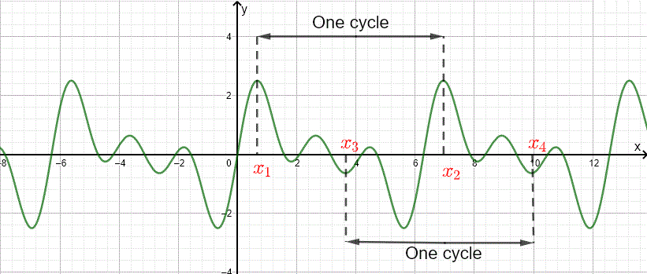
Figure 1.1: A periodic function

- If $f$ and $g$ are any two periodic functions with common period $T$, then their product $fg$ and any linear combination $c_{1}f+c_{2}g$ are also periodic with period $T$.
- For proving the statement, let $F(x)=c_{1}f(x)+c_{2}g(x)$; then for any $x$
$$F(x+T)=c_{1}f(x+T)+c_{2}g(x+T)=c_{1}f(x)+c_{2}g(x)=F(x)$$

- Orthogonality of the Sine and Cosine Functions. The standard inner product $(u,v)$ of two real-valued functions $u$ and $v$ on the interval $α≤x≤β$ is defined by
$$(u,v)=\int_{α}^{β}{ }u(x)v(x)dx.$$
- Let, $u$ and $v$ are said to be orthogonal on $α≤x≤β$ if inner product is 0 that is, if
$$\int_{α}^{β}{ }u(x)v(x)dx=0.$$

- A set of functions is said to be mutually orthogonal if each distinct pair of functions in the set is orthogonal.
- The functions $sin⁡(mπx/L)$ and $cos⁡(mπx/L),m=1,2,…$ resulted to a mutually orthogonal set of functions on the interval $-L≤x≤L$.
- The following orthogonality relations is satisfied:
$$\begin{matrix}\int_{-L}^{L}{ } \cos{\frac{mπx}{L}\cos{\frac{nπx}{L}dx}}=\left\{\begin{matrix}0, & m≠n, \\ L, & m=n;\end{matrix}\right. (6) \\ \int_{-L}^{L}{ } \cos{\frac{mπx}{L}\sin{\frac{nπx}{L}dx}}=0, \text{ all }m,n; (7) \\ \int_{-L}^{L}{ } \sin{\frac{mπx}{L}\sin{\frac{nπx}{L}dx}}=\left\{\begin{matrix}0, & m≠n, \\ L, & m=n.\end{matrix}\right. (8)\end{matrix}$$

- To derive Eq. (8) by direct integration:
$$\begin{matrix}\int_{-L}^{L}{ } sin⁡\frac{mπx}{L}sin⁡\frac{nπx}{L}dx & =\frac{1}{2}\int_{-L}^{L}{ } \left[cos⁡\frac{(m-n)πx}{L}-cos⁡\frac{(m+n)πx}{L}\right]dx \\ & ={\left.\frac{1}{2}\frac{L}{π}\left\{\frac{sin⁡[(m-n)πx/L]}{m-n}-\frac{sin⁡[(m+n)πx/L]}{m+n}\right\}\right|}_{-L}^{L} \\ & =0\end{matrix}$$
- On the other hand, if $m-n=0$, then $m=n$, and the integral must be evaluated in
series in a different way.
$$\begin{matrix}\int_{-L}^{L}{ } sin⁡\frac{mπx}{L}sin⁡\frac{nπx}{L}dx & =\int_{-L}^{L}{ } {\left(sin⁡\frac{mπx}{L}\right)}^{2}dx \\ & =\frac{1}{2}\int_{-L}^{L}{ } \left[1-cos⁡\frac{2mπx}{L}\right]dx \\ & ={\left.\frac{1}{2}\left\{x-\frac{sin⁡(2mπx/L)}{2mπ/L}\right\}\right|}_{-L}^{L} \\ & =L.\end{matrix}$$

- The Euler-Fourier Formulas. Now let us suppose that a series of the form (1) converges, and let us call its $sum⁡f(x)$ :
$$f\left(x\right)=\frac{a_{0}}{2}+\sum_{m=1}^{∞}{ }\left(a_{m}\cos{\frac{mπx}{L}}+b_{m}\sin{\frac{mπx}{L}}\right). (9)$$
- The coefficients $a_{m}$ and $b_{m}$ can be related with $f(x)$ as a result of orthogonality conditions.
- First multiplication of (9) with $cos⁡(nπx/L)$, where $n>0$, and integration with respect to $x$ from $-L$ to $L$. The integration assumed to be progressive term by term,
$$\begin{matrix}\int_{-L}^{L}{ } f\left(x\right)\cos{\frac{nπx}{L}dx}= & \frac{a_{0}}{2}\int_{-L}^{L}{ } \cos{\frac{nπx}{L}dx}+\sum_{m=1}^{∞}{ } a_{m}\int_{-L}^{L}{ } \cos{\frac{mπx}{L}\cos{\frac{nπx}{L}dx}} \\ & +\sum_{m=1}^{∞}{ } b_{m}\int_{-L}^{L}{ } \sin{\frac{mπx}{L}\cos{\frac{nπx}{L}dx}}\end{matrix}(10)$$

- $n$ is fixed when $m$ ranges over the positive integers, it follows from the orthogonality relations (6) and (7) that the only nonzero term on the right side of Eq. (10) is the one for which $m=n$ in the first summation. Then,
$$\int_{-L}^{L}{ }f\left(x\right)\cos{\frac{nπx}{L}dx}=La_{n}, n=1,2,… \left(11\right)$$

- The $b_{n}$ value can be represented by multiplying (9) by $sin(nπx/L)$. Then, integrating term wise from $-L$ to $L$ and using the orthogonality relations from (7) and (8);
$$b_{n}=\frac{1}{L}\int_{-L}^{L}{ }f\left(x\right)\sin{\frac{nπx}{L}dx}, n=1,2,3,…. (14)$$
- The Equation (14) is known as the Euler-Fourier formula for the coefficients in a Fourier series.

Example :
Fourier series converging to the function $f$ is
$$\begin{matrix}f(x)=\left\{\begin{matrix}-x, & -2≤x<0 \\ x, & 0≤x<2\end{matrix}\right. \\ f(x+4)=f(x)\end{matrix}$$
Determine the coefficients.
- The function is an example of a triangular wave (see Figure 1.2) Thus in this case $L=2$, and the function periodic with 4.
- Fourier series has the initial form (16):
$$f\left(x\right)=\frac{a_{0}}{2}+\sum_{m=1}^{∞}{ }\left(a_{m}\cos{\frac{mπx}{2}}+b_{m}\sin{\frac{mπx}{2}}\right) (16)$$
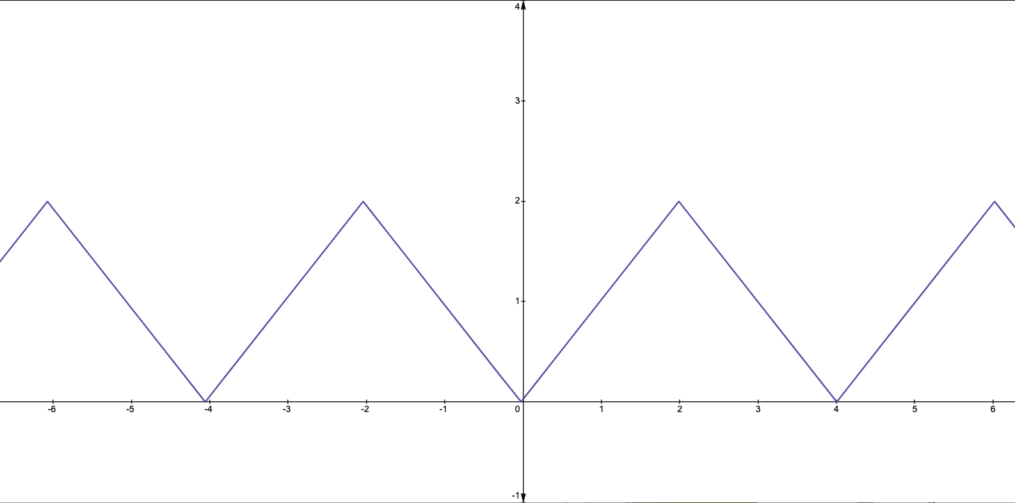
Figure 1.2. A Triangular wave.
- After determination of the coefficients, the Fournier series have the final version in the following
$$\begin{matrix}f(x) & =1-\frac{8}{π^{2}}\left(cos⁡\frac{πx}{2}+\frac{1}{3^{2}}cos⁡\frac{3πx}{2}+\frac{1}{5^{2}}cos⁡\frac{5πx}{2}+⋯\right) \\ & =1-\frac{8}{π^{2}}∑_{m=135}^{∞} \frac{cos⁡(mπx/2)}{m^{2}} \\ & =1-\frac{8}{π^{2}}∑_{n=1}^{∞} \frac{cos⁡(2n-1)πx/2}{(2n-1)^{2}}\end{matrix}$$
Heat Conduction in a Rod (Textbook Ch 10.5)
Linear equations of second order:
- The Heat Equation
- The Wave Equation
- The Potential Equation ( also Laplace’s Equation)

- Consider a conduction heat equation issue for a straight bar of homogenous material with a uniform cross-section. Let the x-axis be set up to follow the axis of the bar ($x=0$and $x=L)$. The bar is entirely heat-insulating, preventing any heat transfer. Temperature, $u$ can be considered constant on the tiny cross sections. Then, the function $u$ relies simply on the $x$ and time $t$.
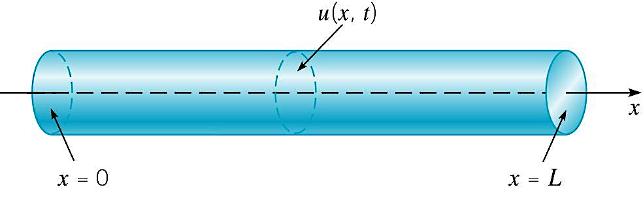

- The variation of temperature in the bar is governed by the heat conduction equation, and has the form
$$α^{2}u_{xx}=u_{t},0<x<L,t>0$$
- where $α^{2}$is a constant known as the thermal diffusivity.
- T₁ at x = 0 and T₂ at x = L, are fixed.
- Initial temperature distribution:
$$u\left(x,0\right)=f\left(x\right),0≤x≤L$$
- Let consider T₁ = T₂ = 0. Thus, there will be boundary conditions:
$$u\left(0,t\right)=0, u\left(L,t\right)=0, t>0$$
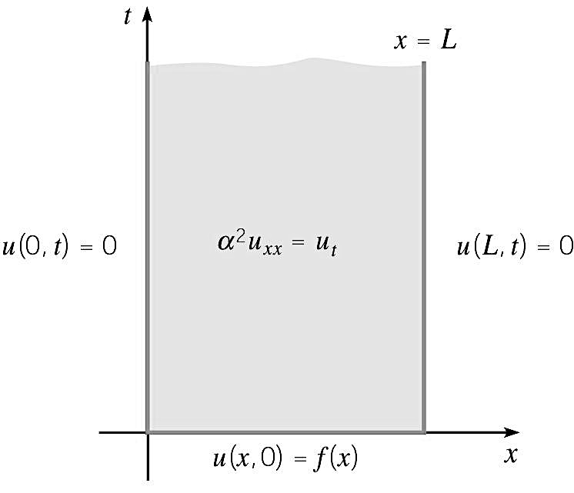
- Focus of the heat equation to find $u(x,t)$ satisfies
all conditions below:
$\begin{aligned}&α^{2}u_{xx}=u_{t}, 0<x<L,t>0 \\ &u(0,t)=0,u(L,t)=0, t>0 \\ &u(x,0)=f(x), 0≤x≤L\end{aligned}$

Heat Equation: Separation of Variables
- Initial form:
$$u\left(x,t\right)=X\left(x\right)T(x)$$
- Substitution into differential equation:
$$α^{2}u_{xx}=u_{t}$$
$$α^{2}X^{''}T=XT^{'}$$
- Let’s use the $-$ for the separation of variables:
$$\frac{X^{''}}{X}=\frac{1}{α^{2}}\frac{T^{'}}{T}=-λ⇒\begin{aligned}X^{''}+λX=0 \\ T^{'}+α^{2}λT=0\end{aligned}$$
- For nontrivial solutions, $X\left(0\right)= 0 and X\left(L\right)=0 instead of T\left(t\right)=0 for t>0.$ Then it follows the following boundary problem:
$$X^{''}+λX=0,X(0)=X(L)=0$$
- The eigenfunctions are nontrivial solutions to this boundary value problem
$$X_{n}(x)=sin⁡(nπx/L), n=1,2,3,… \\ λ_{n}=n^{2}π^{2}/L^{2}, n=1,2,3,…$$
- The solution for the first order equation of $T^{'}+α^{2}λT=0$ is:
$T_{n}=k_{n}e^{-(nπα/L)^{2}t}, k_{n} constant$
- Therefore, the fundamental solutions:
$$u_{n}(x,t)=e^{-(nπα/L)^{2}t}sin⁡(nπx/L),n=1,2,3,…$$
There are many applications of Heat Equation; please see textbook.

Summary:
- Heat Conduction Problem
$$\begin{aligned}α^{2}u_{xx}=u_{t},0<x<L,t>0 \\ u(0,t)=0,u(L,t)=0,t>0 \\ u(x,0)=f(x),0≤x≤L\end{aligned}$$
- The solution is:
$$u\left(x,t\right)=\sum_{n=1}^{∞}{ }c_{n}e^{-(\frac{nπα}{L)^{2}t}}\sin\left(\frac{nπx}{L}\right)$$ where
$$c_{n}=\frac{2}{L}\int_{0}^{L}{ }f\left(x\right)\sin\left(\frac{nπx}{L}\right)dx.$$
Wave Equation: Vibrating String (Textbook Ch 10.7)
- $x=0$ and $x=L$ denote the two ends of the string and the x-axis limits.
- $u(x,t)$ vertical displacement function of the string at the point x at time t.
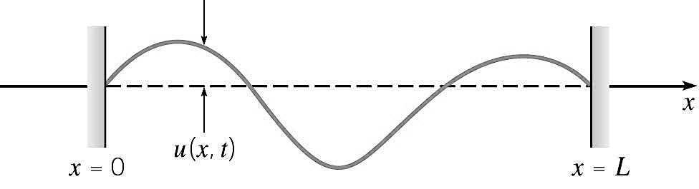
- Wave equation problem is:
$$\begin{aligned}&a^{2}u_{xx}=u_{tt}, 0<x<L, t>0 \\ & \\ u\left(0,t\right)=0 , u\left(L,t\right)=0, t≥0 \\ & \\ u\left(x,0\right)=f\left(x\right), u_{t}\left(x,0\right)=g\left(x\right), 0≤x≤L\end{aligned}$$
- The constant coefficient $a^{2}$ is given $a^{2}=T/$ where T is the tension, ρ is the mass.

- Separation of Variables
- Initial form:
$$u\left(x,t\right)=X\left(x\right)T(x)$$
- Substitution into differential equation:
$$α^{2}u_{xx}=u_{t}$$
$$α^{2}X^{''}T=XT^{'}$$
- Let’s use the $-$ for the separation of variables:
$$\frac{X^{''}}{X}=\frac{1}{α^{2}}\frac{T^{'}}{T}=-λ⇒\begin{aligned}X^{''}+λX=0 \\ T^{'}+α^{2}λT=0\end{aligned}$$
- Boundary Conditions
- For nontrivial solutions, $X\left(0\right)= 0 and X\left(L\right)=0 instead of T\left(t\right)=0 for t>0.$ Then it follows the following boundary problem:
$$X^{''}+λX=0,X(0)=X(L)=0$$

- Eigenvalues and Eigenfunctions
- The eigenfunctions are nontrivial solutions to this boundary value problem
$$X_{n}(x)=sin⁡(nπx/L), n=1,2,3,… \\ λ_{n}=n^{2}π^{2}/L^{2}, n=1,2,3,…$$
- The solution for the equation of $T^{'}+α^{2}λT=0$ is:
$$T(t)=k_{1}cos⁡(nπat/L)+k_{2}sin⁡(nπat/L)$$
where $k_{1},k_{2}$ are constants. Since $T^{'}\left(0\right)=0, k_{2}=0$, and hence
$$T(t)=k_{1}cos⁡(nπat/L)$$

- Fundamental Solution
- Fundamental solutions have the form
$$u_{n}(x,t)=sin⁡(nπx/L)cos⁡(nπat/L), n=1,2,3,…$$
- Assume
$$u(x,t)=\sum_{n=1}^{∞}{ }c_{n}u_{n}(x,t)=\sum_{n=1}^{∞}{ }c_{n}sin⁡(nπx/L)cos⁡(nπat/L)$$
where the $c_{n}$ are chosen so that the initial condition is satisfied:
$$u(x,0)=f(x)=\sum_{n=1}^{∞}{ }c_{n}sin⁡(nπx/L)⇒c_{n}=\frac{2}{L}\int_{0}^{L}{ }f(x)sin⁡(nπx/L)dx$$
There are many applications of Wave Equation; please see textbook.

Summary
- Vibrating string problem
$$\begin{matrix} & a^{2}u_{xx}=u_{tt}, 0<x<L, t>0 \\ & u(0,t)=0,u(L,t)=0, t≥0 \\ & u(x,0)=f(x),u_{t}(x,0)=0, 0≤x≤L\end{matrix}$$
- Solution
$$u(x,t)=\sum_{n=1}^{∞}{ }c_{n}sin⁡(nπx/L)cos⁡(nπat/L)$$
where
$c_{n}=\frac{2}{L}\int_{0}^{L}{ }f\left(x\right)\sin\left(\frac{nπx}{L}\right)dx$.
Laplace’s Equation (Textbook Ch 10.8)
- The equation initial forms (2-dimensions and 3-dimensions respectively):
$$\begin{aligned}u_{xx}+u_{yy}=0 \\ u_{xx}+u_{yy}+u_{zz}=0\end{aligned}$$
- No initial conditions to be satisfied.
- Some boundary conditions according to bounding curve or surface of the region can be occur.
- Laplace’s equation is of second order. Then, two boundary conditions are required.
Dirichlet Problem vs Neumann Problem
- Dirichlet problem: Given boundary conditions is known for Laplace’s equation.
- Neumann problem: Values of the normal derivative are prescribed on the boundary known for Laplace’s equation.

Dirichlet Problem for a Rectangle :
- Drichlet Problem:
$$\begin{aligned}&u_{xx}+u_{yy}=0,0<x<a, 0<y<b \\ &u(x,0)=0,u(x,b)=0, 0<x<a \\ &u(0,y)=0,u(a,y)=f(y), 0≤y≤b\end{aligned}$$
- Solution is
$u\left(x,y\right)=\sum_{n=1}^{∞}{ }c_{n}\sinh\left(\frac{nπx}{b}\right)\sin\left(\frac{nπy}{b}\right)$ where $$c_{n}=\frac{2}{b}sinh⁡{\left(\frac{nπa}{b}\right)}^{-1}\int_{0}^{b}{ }f(y)sin⁡(nπy/b)dy$$
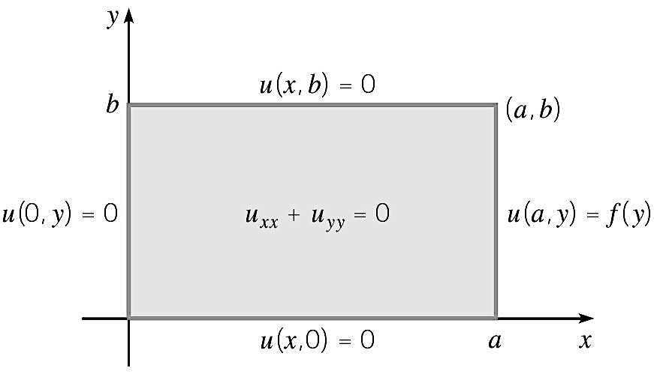

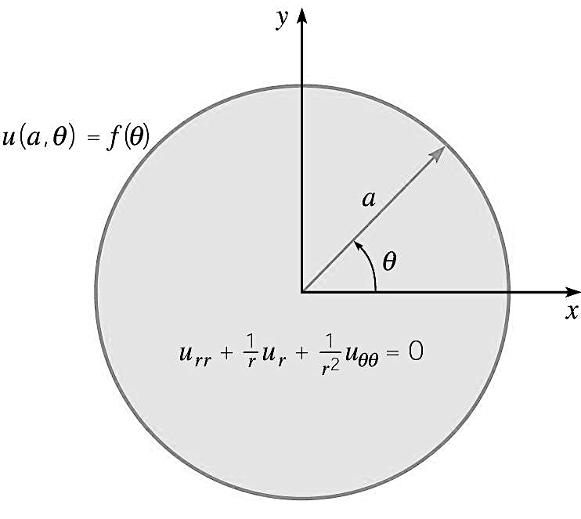
Dirichlet Problem on a Circle :
- Drichlet Problem:
$$u_{rr}+\frac{1}{r}u_{r}+\frac{1}{r^{2}}u_{θθ}=0 \\ u(a,θ)=f(θ),0≤θ<2π$$
- Solution is
$$u\left(r,θ\right)=\frac{c_{0}}{2}+\sum_{n=1}^{∞}{ }r^{n}\left(c_{n}\cos{nθ}+k_{n}\sin{nθ}\right) where \\ c_{n}=\frac{1}{a^{n}π}\int_{0}^{2π}{ }f\left(θ\right)\cos{nθdθ}, k_{n}=\frac{1}{a^{n}π}\int_{0}^{2π}{ }f(θ)sin⁡nθdθ$$

There are many applications of Laplace’s Equation; please see textbook.

