Ordinary Differential Equations

Instructor: Prof.Dr.Ayşe Hümeyra Bilge
e-mail:ayse.bilge@khas.edu.tr:phone:0 533 267 44 12
Textbook:
- Elementary Differential Equations and Boundary Value Problems.Ed8,BoyceR.C.DiPrima.JWS

Foreward:
- These lecture notes aim to review the material of the standard 2nd year differential equations course of engineering curricula and supplement it with an introduction to the study of partial differential equations.
- Ordinary differential equations are used in many engineering applications.
  - First order ODE’s describe many growth and decay phenomena.
  - Second order ODE’s describe osciallatory phenomena.
  - Series solutions are needed for the study of for example Bessel funcions that describe propagation of waves.
  - The method of Laplace transform is used in taking into account initial conditions.
  - Systems of ODE’s are used as models for all linear systems and find important applications in control theory. re are many fine textbooks part on ordinary differential equations is based
- Partial differential equations solvable by the method of separation of variables are also studied in a first course in differential equations. These topics are presented under the PDE headings.

The notes on ODE’S consist of the following parts
- Part 1: First order ordinary differential equations
- Part 2: Higher order ordinary differential equations
- Part 3: Series solutions
- Part 4: Laplace transform
- Part 5: Systems of ODE’s

Part 3
Series Solutions

Series Solutions
We use this method for second order lineer equation with non-constant coefficient
$$P\left(x\right)\frac{d^{2}y}{dx^{2}}+φ\left(x\right)\frac{dy}{dx}+R\left(x\right)y=0$$
We work with the form:
$$\frac{d^{2}y}{dx^{2}}+p\left(x\right)\frac{dy}{dx}+q\left(x\right) y=0$$
If, at $x=x_{0}$, $p(x_{0})$ and q$(x_{0})$ are continuous, then $x_{0}$ is an ordinary point. Other wise it is a singular point.

If $x_{0}$is a singular point we look at the limits:
$\lim_{x→x_{0}}{p(x)(x-}x_{0})$ and ${\lim_{x→x_{0}}{q(x)(x-}x_{0})}^{2}$

If both limits exist, then $x_{0}$ is a regular singular point, otherwise it is an irregular singular point.
Ex
- Bessel’s eqn : $x^{2}y^{''}+xy^{'}+\left(x^{2}-y^{2}\right)y=0, x_{0}=0$regular singular point
- Legendre’s eqn: $\left(1-x^{2}\right)y^{''}-2xy^{'}+∝\left(∝+1\right)y=0, x_{0}=±1$ regular singular point
- $\left(1+x^{2}\right)y^{''}+2xy^{'}+4x^{2}y=0$ no singular point.

Ex: $2x{\left(x-2\right)}^{2}y^{''}+3xy^{'}+\left(x-2\right)y=0$
$x=0$ regular singular point
$x=2$irregular singular point
- We will not study solutions near irregular singular points

Series solutions near an ordinary point
If $x_{0}$ is an ordinary point, then the solution is of the form
$$y=a_{0}+a_{1}\left(x-x_{0}\right)+…..+a_{0}{\left(x-x_{0}\right)}^{n}+……=\sum_{n=0}^{∞}{a_{n}{\left(x-x_{0}\right)}^{n}}$$
Ex. $y^{''}-xy=0$ Airy’s eqn. $x_{0}=0$
$y=\sum_{n=0}^{∞}{a_{n}x^{n}}$,
$$y^{'}=\sum_{n=0}^{∞}{a_{n}nx^{n-1}=}\sum_{n=1}^{∞}{a_{n}nx^{n-1}},$$
$$y''=\sum_{n=1}^{∞}{a_{n}n{\left(n-1\right)x}^{n-2}=}\sum_{n=2}^{∞}{a_{n}n{\left(n-1\right)x}^{n-2}}$$
Substititute in the differential equation to get
$$\sum_{n=2}^{∞}{a_{n}n{\left(n-1\right)x}^{n-2}}-x\sum_{n=0}^{∞}{a_{n}x^{n}=}0$$
$$\sum_{n=2}^{∞}{a_{n}n{\left(n-1\right)x}^{n-2}}-\sum_{n=0}^{∞}{a_{n}x^{n+1}=}0$$
The first sum start at $x^{0}$ for $n=2$. We split the sum:
$$a_{2}2.1x^{0}+\underset{both start at x^{1} shift indices}{\underbrace{\sum_{n=3}^{∞}{a_{n}n\left(n-1\right)x^{n-2}-\sum_{n=0}^{∞}{a_{n}x^{n+1}}}}=0}⟹a_{2}=0$$
In the first sum put $k=n-2 n=k+2$
$$⇒\sum_{k=1}^{∞}{a_{k+2}\left(k+2\right)}\left(k+1\right)x^{k}-\underset{put k=n+1 n=k-1}{\underbrace{\sum_{n=0}^{∞}{a_{n}x^{n+1}}}}=0$$
$$⇒\sum_{k=1}^{∞}{a_{k+2}\left(k+2\right)}\left(k+1\right)x^{k}-\sum_{k=1}^{∞}{a_{k-1}}x^{k}=0⇒\sum_{k=1}^{∞}{{\{a}_{k+2}\left(k+2\right)}\left(k+1\right){-a_{k-1}\}x}^{k}=0$$
$$⟹a_{k+2}=\frac{a_{k-1}}{\left(k+1\right)\left(k+2\right)}⟹ recursion relation k=1,2,3……$$
$$a_{3}=\frac{a_{0}}{2.3} , a_{6}=\frac{a_{3}}{5.6}=\frac{a_{0}}{2.3.5.6} , a_{9}=\frac{a_{6}}{8.9}=\frac{a_{0}}{2.3.5.6.8.9}⟹ solution y_{1}$$
$$a_{4}=\frac{a_{1}}{3.4} , a_{7}=\frac{a_{1}}{3.4.6.7} , a_{10}=\frac{a_{1}}{3.4.6.7.9.10} ⟹ solution y_{2}$$

Series solutions near a regular singular point
If $x_{0}$ is a regular singular point, we start with
$$y=\sum_{n=0}^{∞}{a_{n}{\left(x-x_{0}\right)}^{n+r} }$$
Where r is a constant to be determined from the coefficient of the lowest order power of x. This coefficient gives the indicial equation, its solutions are called the exponents at the singularity, $r_{1}$ and $r_{2}$, with $r_{1}≥r_{2}$
- If $r_{1}-r_{2}$ is not an integer, the series method gives two lineanly independent solutions with exponents $r_{1}$and $r_{2}$
- If $r_{1}-r_{2}$ is an integer,we use the larger root $r_{1}$to get one solution, the other solution is logarithmic, i.e it involves $\ln\left(x-x_{0}\right)$

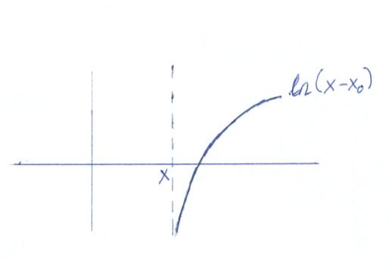
The logarithmic solution diverges as x approaches x₀.

Ex: Bessel’s equation of order k
$$x^{2}y^{''}+xy^{'}+\left(x^{2}-k^{2}\right)y=0$$
$y=\sum_{n=0}^{∞}{a_{n}x^{n+r}}$,
$y^{'}=\sum_{n=0}^{∞}{a_{n}{\left(n+x\right)x}^{n+r-1}}$ ,
$$y''=\sum_{n=0}^{∞}{a_{n}{\left(n+r\right)\left(n+r-1\right)x}^{n+r-2}}$$
Substitute in the equation
$$x^{2}\sum_{n=0}^{∞}{a_{n}{\left(n+r\right)\left(n+r-1\right)x}^{n+r-2}}+x\sum_{n=0}^{∞}{a_{n}{\left(n+r\right)x}^{n+r-1}}+x^{2}\sum_{n=0}^{∞}{a_{n}x^{n+r}}-k^{2}\sum_{n=0}^{∞}{a_{n}x^{n+r}}=0$$

$$⟹\sum_{n=0}^{∞}{a_{n}{\left(n+r\right)\left(n+r-1\right)x}^{n+r}+\sum_{n=0}^{∞}{a_{n}{\left(n+r\right)x}^{n+r}+}}\sum_{n=0}^{∞}{a_{n}x^{n+r+2}}-k^{2}\sum_{n=0}^{∞}{a_{n}x^{n+r}}=0$$
Collect the series with $x^{n+r}$
$$⟹\sum_{n=0}^{∞}{\left[a_{n}{\left(n+r\right)\left(n+r-1\right)+a_{n}{\left(n+r\right)- a_{n}}^{ }k^{2} }^{ }\right]}x^{n+r}+\sum_{n=0}^{∞}{a_{n}x^{n+r+2}=0}$$
$$⟹\sum_{n=0}^{∞}{a_{n}\left[{\left(n+r\right)\left(n+r-1\right)+{\left(n+r\right)- }^{ }k^{2} }^{ }\right]}x^{n+r}+\sum_{n=0}^{∞}{a_{n}x^{n+r+2}}=0$$
Start writing the first few terms:
$$⟹a_{0}\left[r\left(r-1\right)+r-k^{2}\right]x^{r}+a_{1}\left[\left(1+r\right)\left(1+r-1\right)+\left(1+r\right)-k^{2}\right]x^{r+1}$$
$$+a_{2}\left[\left(2+r\right)\left(2+r-1\right)-k^{2}\right]x^{r+2}+…………..$$
$+a_{0}x^{r+2}+a_{1}x^{r+3}+a_{2}x^{r+4}+………………….$=0
The lowest order term is $x^{r}$. Its coefficient gives the indicial equation
$r\left(r-1\right)+r-k^{2}=0⟹ r^{2}-k^{2}=0 r^{2}=k^{2} r_{1}=k , r_{2}=-k$

Ex: i)

$k=0$, $r_{1}-r_{2}=0$ one solution has exponent $r_{1}=0$ at $x=0$.
It is called $J_{0}$ .
The other solution is logarithmic. It is called $Y_{0}$
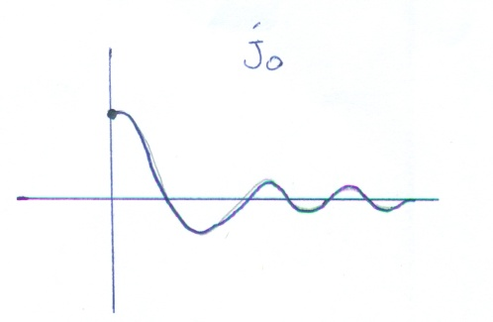

ii) $k=1 ,$ $r_{1}-r_{2}=1-\left(-1\right)=2$ is an integer. The first solution has exponant 1 at $x=0$, i.e., the series starts at
$y=J_{1}\left(x\right)=a_{0}x+a_{1}x^{2}+….J_{1}\left(x\right)$ is zero at $x=0$

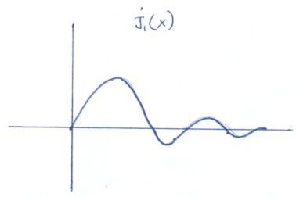

The other solution is logaritmic.

iii) $k=\frac{1}{3}$ $r_{1}=\frac{1}{3}$ $r_{2}=-\frac{1}{3}$ , $r_{1}-r_{2}=\frac{2}{3}$ is not an integer.
$J_{\frac{1}{3}}\left(x\right)≃a_{0}x^{\frac{1}{3}}+a_{1}x^{\frac{4}{3}}+…..$ it is zero at $x=0$
$J_{-\frac{1}{3}}\left(x\right)≃a_{0}x^{-\frac{1}{3}}+a_{1}x^{\frac{2}{3}}+…..$ it diverges as x$→0$
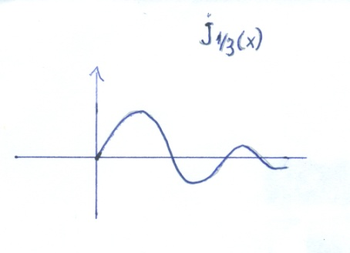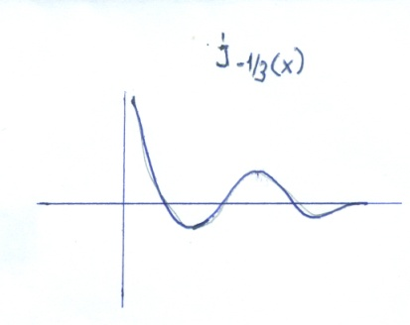

Example (In the text book)
$$2x^{2}y^{''}-xy^{'}+\left(1+x\right)y=0$$
$y=\sum_{n=0}^{∞}{a_{n}x^{n+r}}$,
$$y^{'}=\sum_{n=0}{a_{n}\left(n+r\right)x^{n+r-1}} ,$$
$$y^{''}=\sum_{n=0}^{∞}{a_{n}\left(n+r\right){\left(n+r-1\right)x}^{n+r-2}}$$
Substitute:
$$0=2\sum_{n=0}^{∞}{a_{n}\left(n+r\right){\left(n+r-1\right)x}^{n+r}}-\sum_{n=0}^{∞}{a_{n}\left(n+r\right)x^{n+r}+\sum_{n=0}^{∞}{a_{n}x^{n+r}+\sum_{n=0}^{∞}{a_{n}x^{n+r+1}=0}}}$$

Lowest order term:${ x}^{r}$
$$n=0⟹ 2a_{0}r\left(r-1\right)x^{r}-a_{0}rx^{r}+a_{0}x^{r}=0$$
$$⟹ 2r\left(r-1\right)-r+1=2r^{2}-3r+1=0$$
$r_{1}=1 r_{2}=\frac{1}{2} r_{1}- r_{2}=\frac{1}{2}$ is not an integer
$$0=\underset{don^{'}t shift index put k=n}{\underbrace{\sum_{n=1}^{∞}{a_{n}\left[2\left(n+r\right)\left(n+r-1\right)-\left(n+r\right)+1\right]}}} x^{n+r}+\underset{\begin{matrix}shift index put k=n+1 \\ n=0 ⟹k=1\end{matrix}}{\underbrace{\sum_{n=0}^{∞}{a_{n}x^{n+r+1}}}}$$
$$0=\sum_{k=1}^{∞}{a_{k}\left[2\left(k+r\right)\left(k+r-1\right)-\left(k+r\right)+1\right]x^{k+r}}+\sum_{k=1}^{∞}{a_{k-1}\left[x^{k+r}\right]}$$
$$0=\sum_{k=1}^{∞}{\underset{=0}{\underbrace{\left\{a_{k}\left[2\left(k+r\right)\left(k+r-1\right)-\left(k+r\right)+1\right]+a_{k-1}\right\}}}}x^{k+r}$$

We obtain the recursion relation
$$a_{k}=-\frac{a_{k-1}}{2\left(k+r\right)\left(k+r-1\right)-\left(k+r\right)+1}$$

Thus, we know the coefficients of the series expansion of the solution. Hence we obtained the solution of the ODE as a series. We need to show that the series is convergent in a certain radius of convergence. Here, it is known that the solution converges everywhere. Hence by solving the Bessel’s equation we obtain new functions defined as series.

QUIZ
1)Are these point ordinary,regular singular point of
$$x^{2}{\left(x+1\right)}^{2}y^{''}+x\left(x-1\right)y^{'}+y=0$$
$$x_{0}=0, x_{0}=-1 x_{0}=1$$

2)Find the first 6 terms of the series solution of
$$y^{''}+xy^{'}+2y=0 near { x}_{0}=0$$
3)Find the indicial equation for $x\left(x-1\right)y^{''}+6x^{2}y^{'}+3y=0$ and determine the exponents of the singularity. Is there a logarithmic solution?

END OF PART 3

