**Notes & Actions**

**Meeting title:** TEAM MEETING AT UNIDEB

***Promoting Deep and Wide Thinking / Early Dual Degrees in Basic Sciences (ThinkBS)***

Project nº: 2019-1-TR01-KA203-077194

**Date:** 02 June 2022

**Location:** Debrecen, Egyetem tér 1, 4032 Hunagry.

**Attending:** Kadir Has University

Halime Beyza Küçükdağ

University of Debrecen

László Kozma, Katalin Tóth

Politehnica of Bucharest

Maria Cristina Dijmarescu, Irina Severin

Universidad San Jorge

África Domingo, Ana Marcén

**Apologies:** Ayşe Hümeyra Bilge

|  |  |  |
| --- | --- | --- |
|  | **Agenda Item** | **Action** |
| 1. | PROGRESS REVIEW | It was discussed about the 24 agreed courses and their material. It was decided to complete the missing contents together with the related lecturers during the transfer process of the website platform. |
| 2. | INTELLECTUAL OUTPUTS | Kadir Has gave information about the designed website(Blended learning platform) template and process to be continued: Tables will be created by dividing each lecture according to its main and sub-titles and the course contents on the website will be gathered under these divided topics. |
| 3. | PLANNING OF EVENTS | We agreed to organize summer courses that will continue for 10 days with different topics as National Agency approved. We re-arranged the dates of the summer courses (attached to the end of this document). The summer course program, content, dissemination tools and draft summer course certificates were prepared and decided to be published in universities and shared with partners until the end of June.  The summer course budgets were discussed and Kadir Has e-mailed the budget details to the partners after the meeting.  Ideas on both face-to-face and online follow-up of summer courses (Hybrid) were discussed in order to be submitted to the National Agency for approval.  Kadir Has will remain available for consulting with their international agency about doubts regarding organization and budgeting from the rest of the partners.  We also agree to run the meetings and multiplier events in parallel with the summer courses. |
| 4. | GROUP PICTURE | Group pictures taken successfully. Attached to the end of this document. |
| 5. | SUMMARY OF AGREEMENTS AND BUDGET CONSIDERATIO NS | Review and confirmation of the agreements taken during the meeting. We agree that each university should be free to run the summer courses as it suits them as long as they include face-to-face activities.  Kadir Has sent the National Agency documents and contents sent within the scope of Covid rules about how the allocation will work if students connect online, by e-mail after the meeting. |
| 6. | QUESTIONS AND COMMENTS | None. |

|  |
| --- |
| **Next Meetings** |
| **Date** | **Location** | **Purpose** |
| 15 July 2022 | Romania | TPM4 |

**Annex I: planning for the meetings, multiplier events, and summer courses**

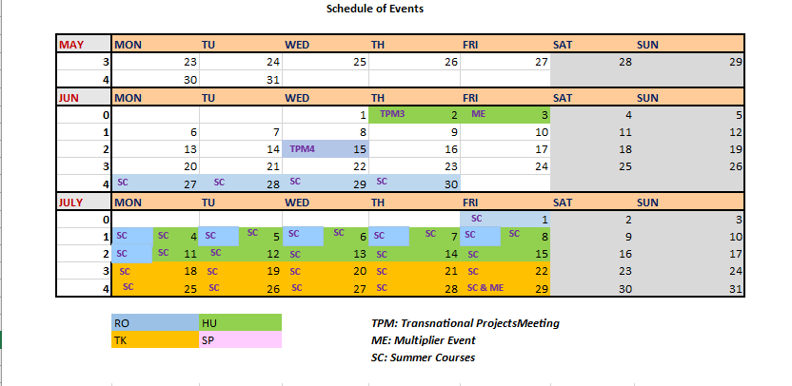

* **TMP4 – Romania: 15 July**
* **Multiplier Event - Turkey: 29 July**
* **Summer Courses:**

**1st Summer Course in Hungary: 4-15 July**

**2nd Summer Course in Romania: 27 June-11 July**

**3rd Summer Course in Turkey: 18-29 July**

**Annex II: Think BS List of Course & Report of Lectures**

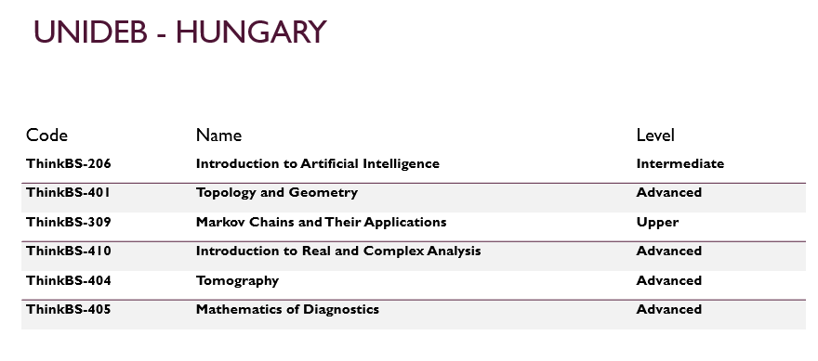

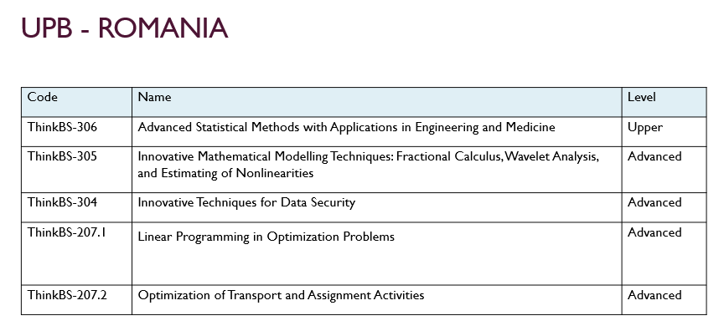

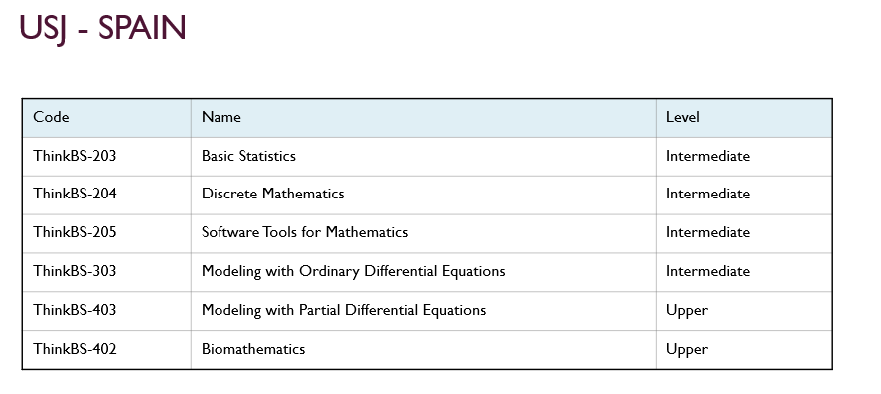

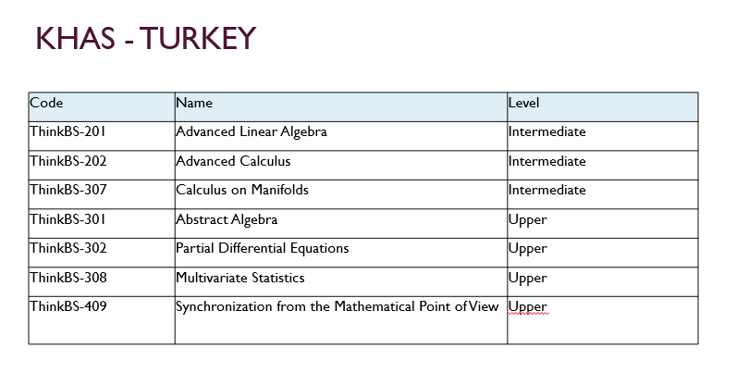

**Annex III: Group picture taken in the meeting:**

